# First Testing – 5th of April

Story 1: Account registration

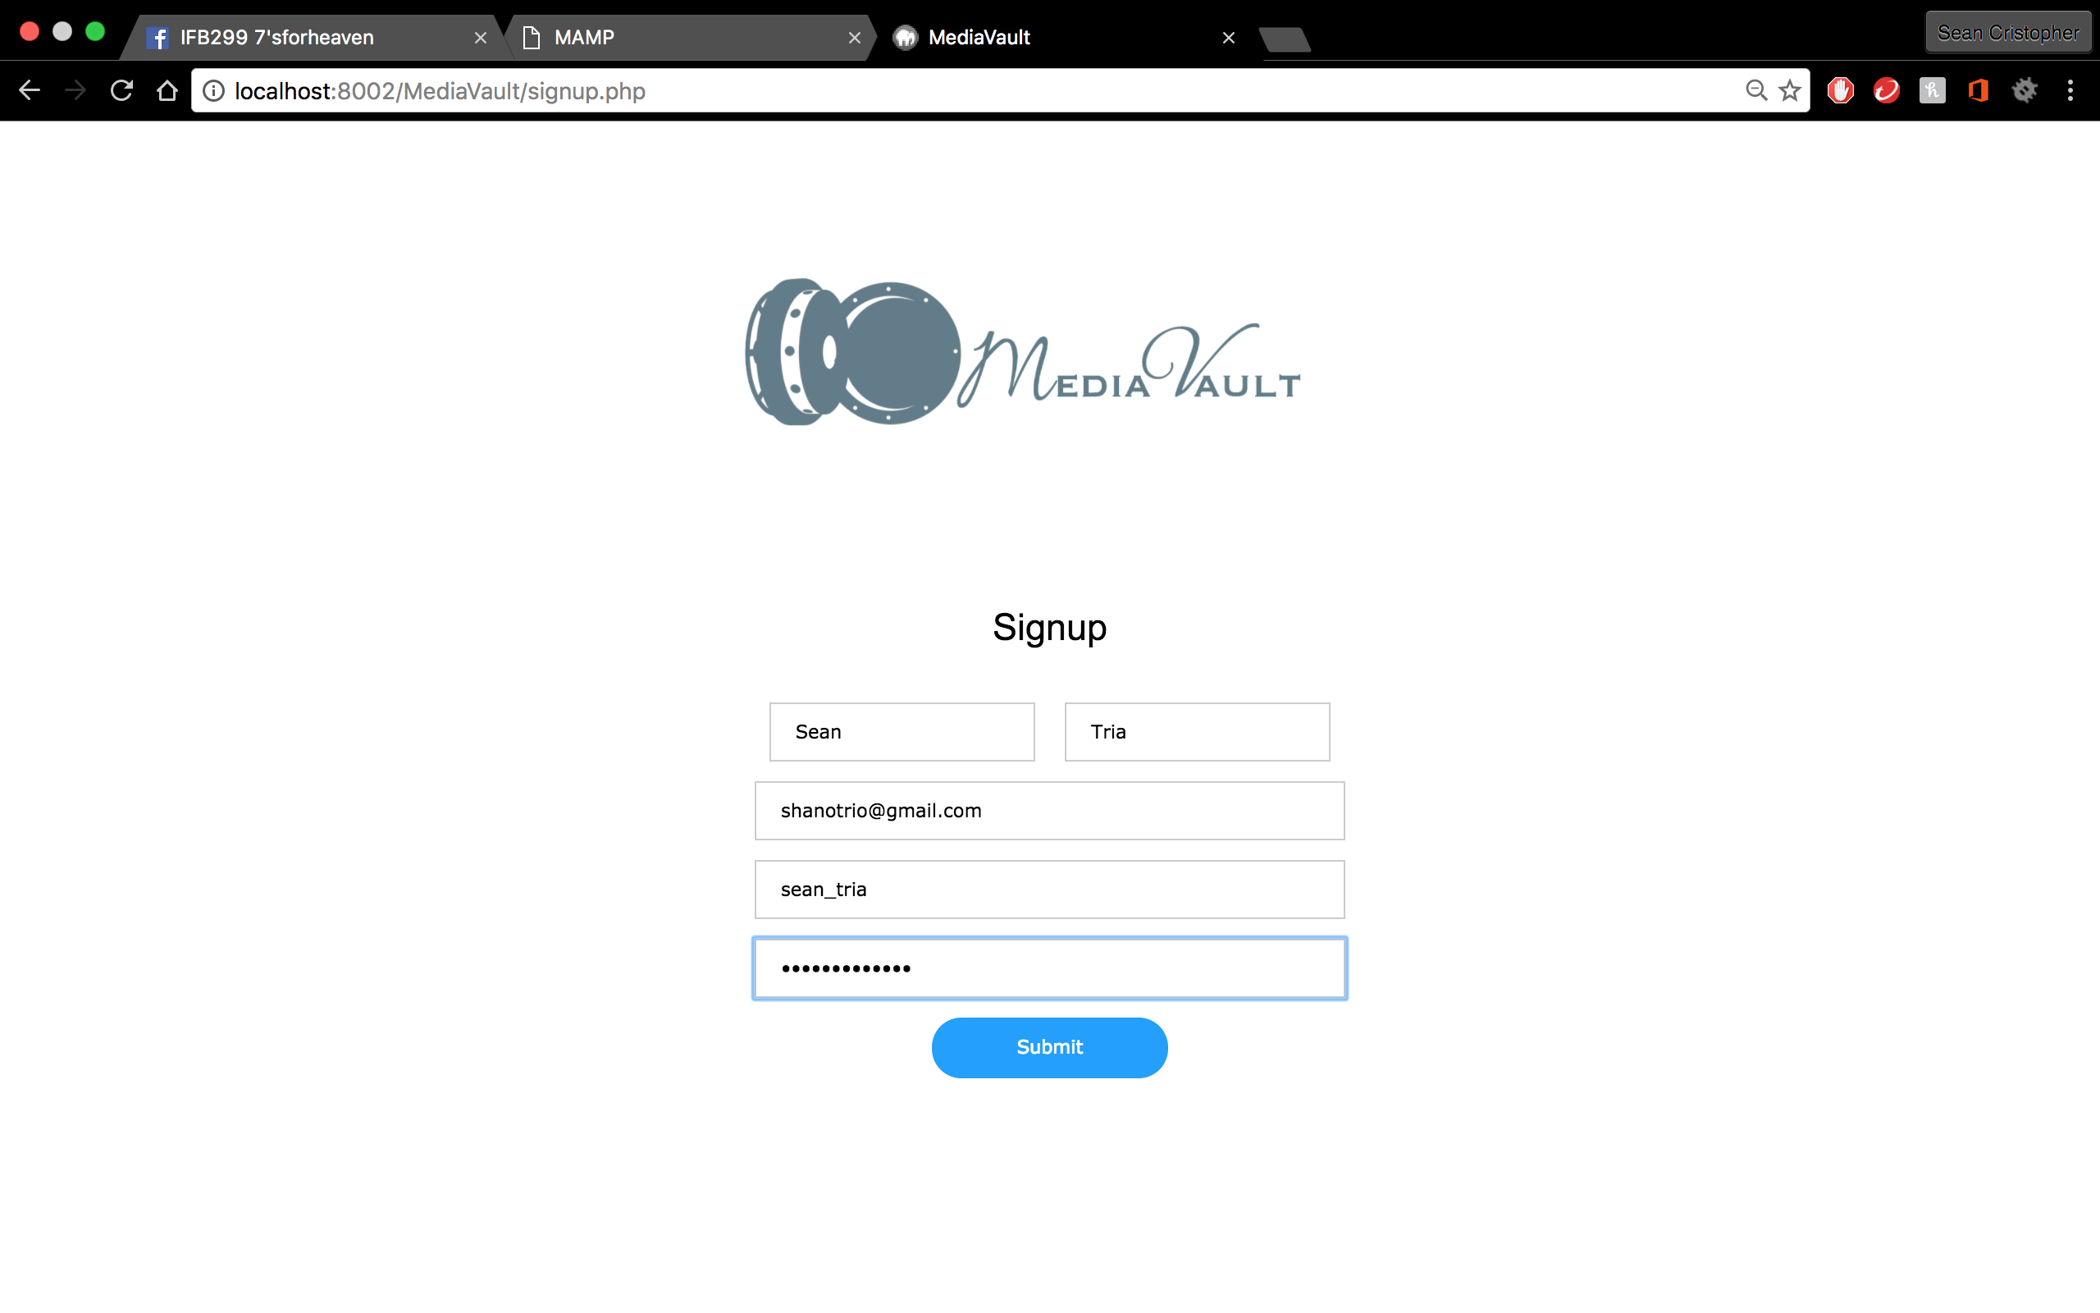

* Sign-up form is working
* User details is unique and cannot be duplicated
* User details is registered to SQL tables
* Doesn’t send email confirmation

Story 4: View my Files

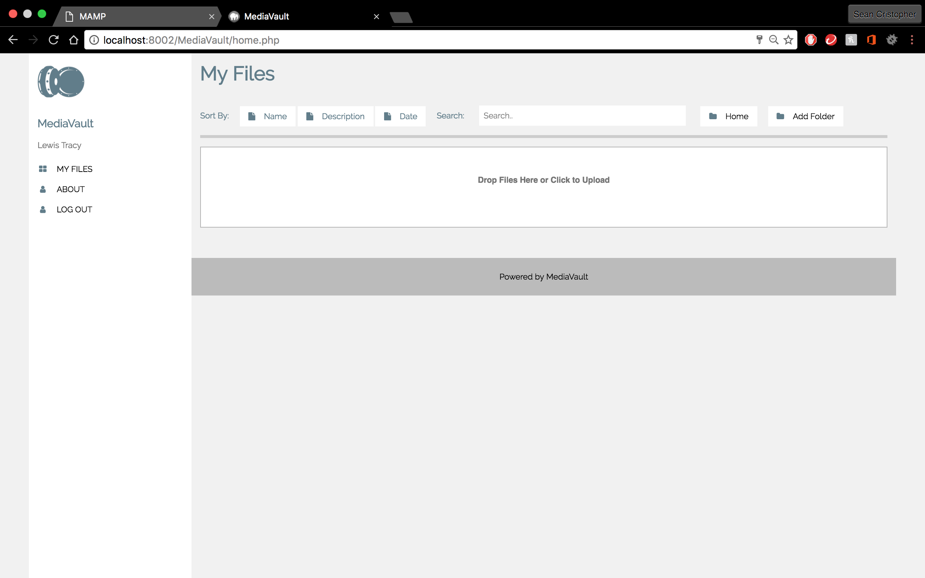

* Landing page successfully opens when login is successful
* Grid shows user’s files
* Grid has empty box for drag and drop and file exploration for upload purposes
* Doesn’t send email confirmation

Story 3: MediaVault Login

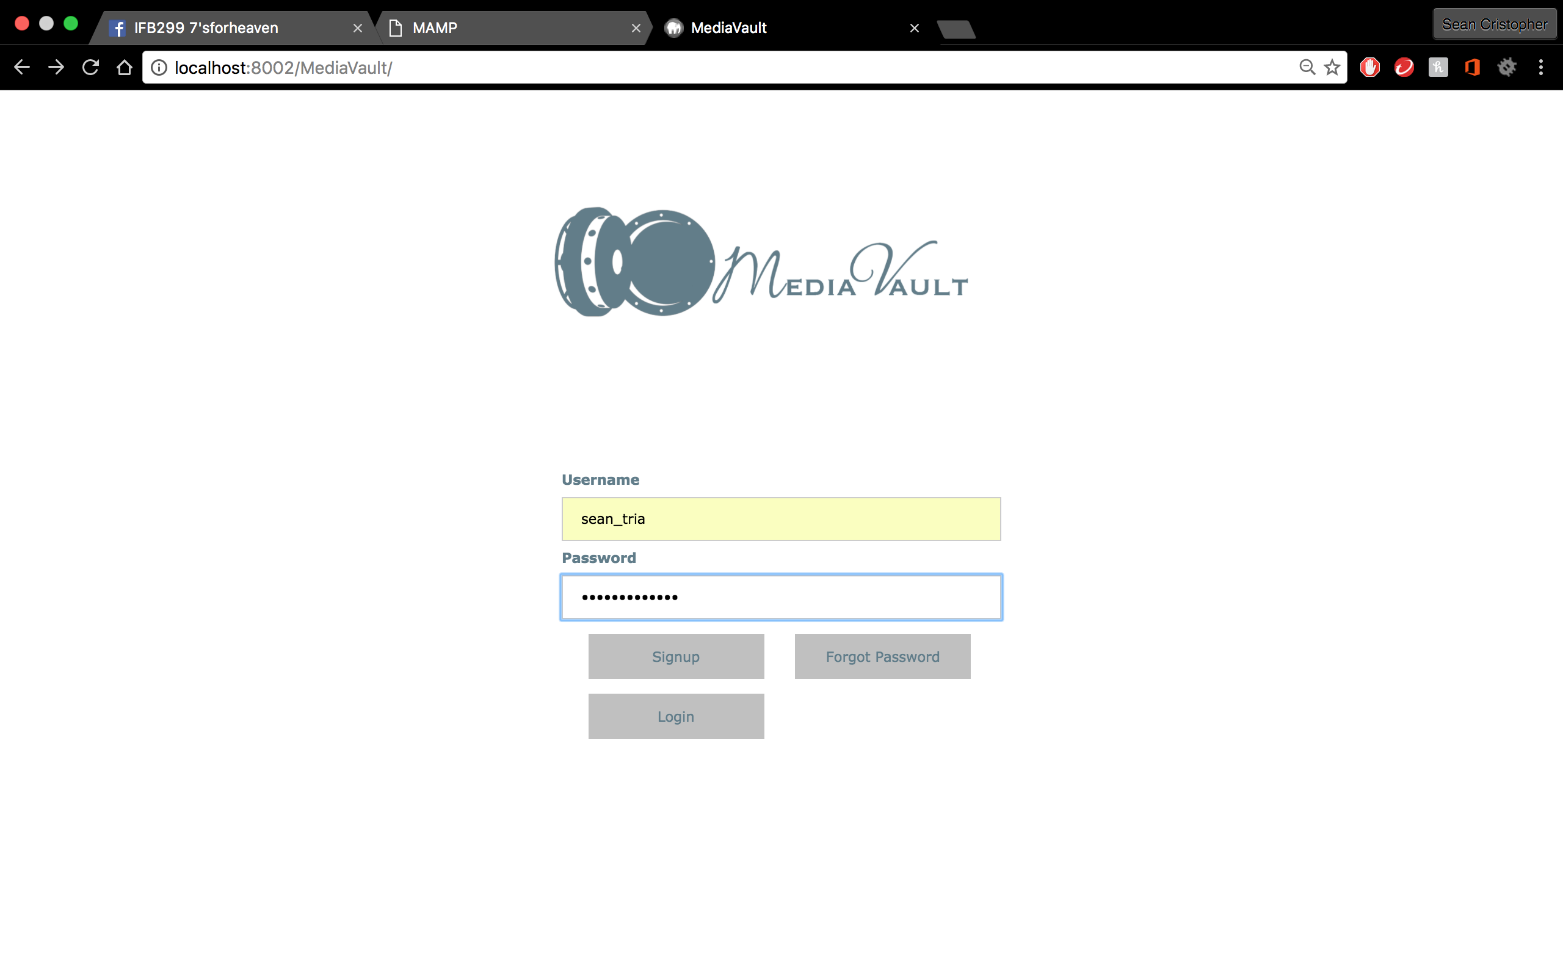 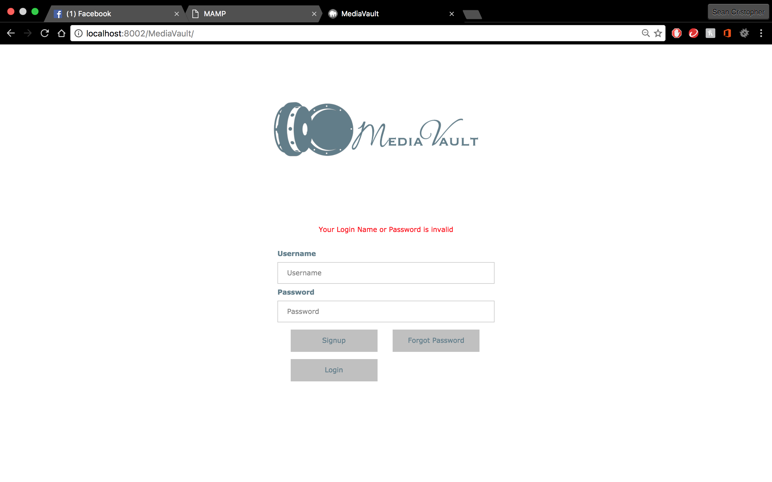

* Login information matches registered information in SQL tables and functions
* Error message pops up if information is incorrect

Summary: Initial testing completed. User stories are working and basic layout of the website is completed